

Data Structures And Algorithms
( Course Code: CSC211 )

Name : Syeda Aima Abbas
Roll No # FA24-BSE-010
Instructor Name : Sir Atique

Assignment # 1
Lab Part

Q#1: Transaction Management using Vectors
A data analytics company stores large sets of customer transaction amounts in a vector for fast indexing and random access. Your task is to implement the following functionalities in C++ using the STL vector:
1. insertTransaction(double amount) – Insert a new transaction at the end of the vector.
2. deleteTransaction(int index) – Delete the transaction at a given index (maintain order of the remaining elements).
3. findAndUpdate(double oldAmount, double newAmount) – Search for all occurrences of a specific transaction amount and update them.
4. calculateStatistics() – Compute and return:
- The total number of transactions
- The maximum transaction
- The minimum transaction
- The average transaction
5. displayTransactionsSorted(bool ascending) – Display all transactions sorted in ascending or descending order.
Example:
Input: 2500, 3200, 1800, 2500, 4000
After deleteTransaction(2): 2500, 3200, 2500, 4000
After findAndUpdate(2500, 2600): 2600, 3200, 2600, 4000
Statistics → count=4, max=4000, min=2600, avg=3100
Sorted (descending): 4000, 3200, 2600, 2600

CODE

#include <iostream>
#include <vector>
#include <algorithm>
using namespace std;

vector<double> list;

void insertTransaction(double val) {
list.push_back(val);
}

void deleteTransaction(int index) {
if (index < 0 || index >= list.size()) {
cout << "Invalid index!" << endl;
return;
}

list.erase(list.begin() + index);
}

void searchAndUpdate(double val, double newValue) {
bool found = false;
for (int i = 0; i < list.size(); i++) {
if (list[i] == val) {
list[i] = newValue;
found = true;
}
}
if (found) {
cout << "Transaction(s) found and updated!" << endl;
} else {
cout << "Transaction not found" << endl;
}
}

void calculateStatistics() {
if (list.empty()) {
cout << "No transactions available!" << endl;
return;
}

double minVal = *min_element(list.begin(), list.end());
double maxVal = *max_element(list.begin(), list.end());
double sum = 0;
for (double val : list) sum += val;
double avg = sum / list.size();

cout << "Maximum transaction is: " << maxVal << endl;
cout << "Minimum transaction is: " << minVal << endl;
cout << "Count is: " << list.size() << endl;
cout << "Average is: " << avg << endl;
}

void sortTransactions(bool ascending) {
if (ascending) {
sort(list.begin(), list.end());
} else {
sort(list.begin(), list.end(), greater<double>());
}

cout << "Transactions sorted: ";
for (double val : list) cout << val << " ";
cout << endl;
}

int main() {
bool continuee=true;
while (continuee) {

cout << "which operation you want to perform" << endl;
cout << "1: Insert a new transaction at the end of the vector." << endl;
cout << "2: Delete the transaction at a given index." << endl;
cout << "3: Search for all occurrences of a specific transaction amount and update them." << endl;
cout << "4: Compute statistics (count, max, min, avg)." << endl;
cout << "5: Display all transactions sorted in ascending or descending order." << endl;
cout << "6:Exit" << endl;

int choice;
cout << "Enter your choice: ";
cin >> choice;

{
if (choice == 1) {
double amount;
cout << "Enter amount: ";
cin >> amount;
insertTransaction(amount);
}
else if (choice == 2) {
int index;
cout << "Enter the index of transaction you want to delete: ";
cin >> index;
deleteTransaction(index);
}
else if (choice == 3) {
double oldAmount, newAmount;
cout << "Enter amount you want to change: ";
cin >> oldAmount;
cout << "Enter new amount: ";
cin >> newAmount;
searchAndUpdate(oldAmount, newAmount);
}
else if (choice == 4) {
calculateStatistics();
}
else if (choice == 5) {
bool ascending;
cout << "Enter 1 for ascending, 0 for descending: ";
cin >> ascending;
sortTransactions(ascending);
}
else if (choice==6){
continuee=false;
cout << "Exiting the program" << endl;
}else{
cout << "Invalid Choice!" << endl;
}

}
}
return 0;
}

OUTPUT
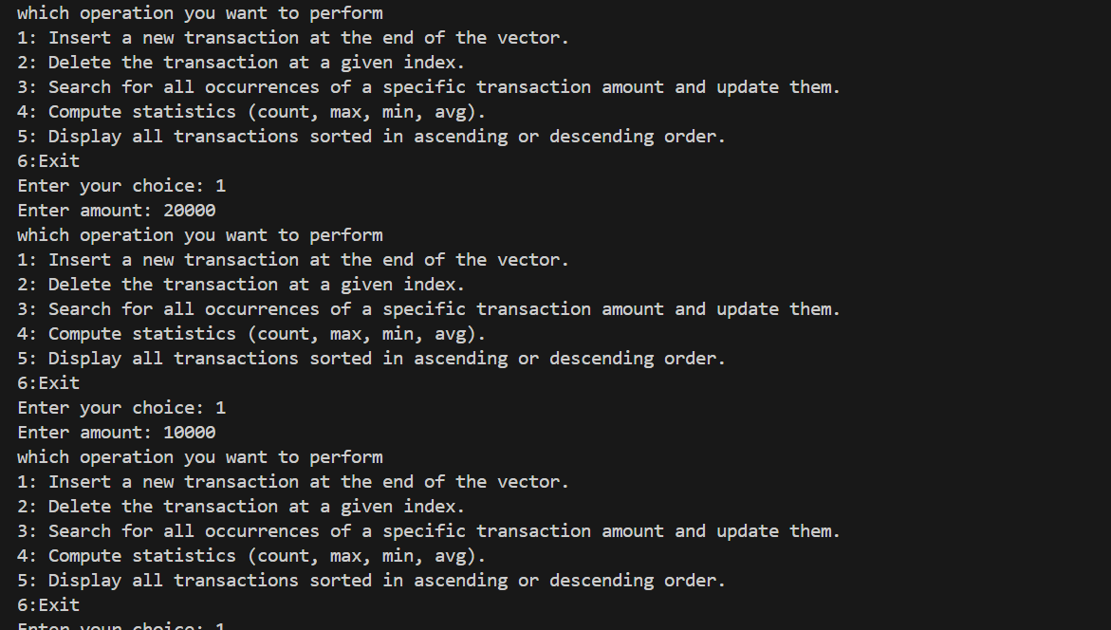

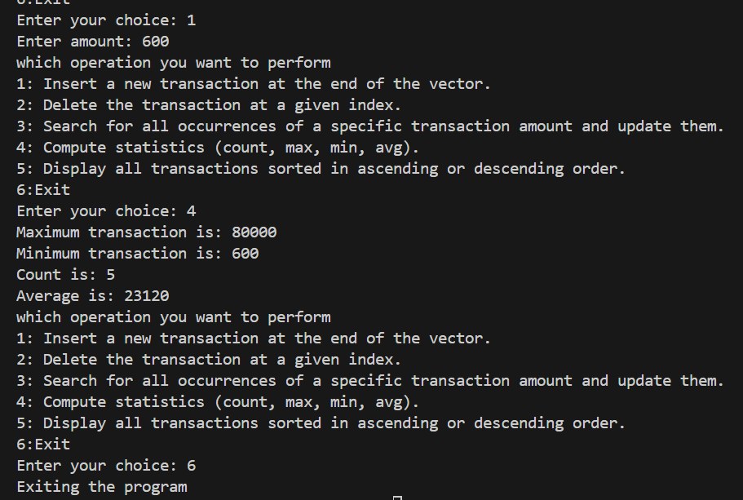

Q#2: Student Marks Split & Sort (Singly Linked List)
A university's student portal is designed to process student performance data in real-time. The system receives an unordered singly linked list of students' final semester marks. For statistical analysis and reporting purposes, the system needs to split the list into two equal halves and sort each half in descending order to be stored separately in two databases (list1 and list2).
Write a C/C++ program that performs this operation and displays the two sorted halves. Assume the number of elements in the list is even.
Example:
Input: 47 -> 33 -> 12 -> 89 -> 21 -> 50 -> 65 -> 30
Output:
list1 is 33 -> 30 -> 21 -> 12
list2 is 89 -> 65 -> 50 -> 47

CODE:
#include <iostream>
using namespace std;

class Node {
public:
int data;
Node *next;

Node(int val) {
data = val;
next = nullptr;
}
};

class SinglyLinkedList {
Node *head;

public:
SinglyLinkedList() {
head = nullptr;
}

void insertAtHead(int val) {
Node *newNode = new Node(val);
newNode->next = head;
head = newNode;
}

void display() {
Node *temp = head;
while (temp != nullptr) {
cout << temp->data << " -> ";
temp = temp->next;
}
cout << "NULL" << endl;
}

void display(Node *h) {
Node *temp = h;
while (temp != nullptr) {
cout << temp->data << " -> ";
temp = temp->next;
}
cout << "NULL" << endl;
}

void sortList(Node *&h) {
if (h == nullptr || h->next == nullptr) return;

Node *curr = h;
while (curr->next != nullptr) {
Node *index = curr->next;
while (index != nullptr) {
if (curr->data > index->data) {
int temp = curr->data;
curr->data = index->data;
index->data = temp;
}
index = index->next;
}
curr = curr->next;
}
}

void splitAndSortList() {
if (head == nullptr) {
cout << "The list is empty" << endl;
return;
}
if (head->next == nullptr) {
cout << "List has one node so already split and sorted" << endl;
return;
}

Node *slow = head;
Node *fast = head->next;

while (fast != nullptr && fast->next != nullptr) {
slow = slow->next;
fast = fast->next->next;
}

Node *head2 = slow->next;
slow->next = nullptr;

sortList(head);
sortList(head2);

cout << "First half sorted: ";
display(head);

cout << "Second half sorted: ";
display(head2);
}
};

int main() {
SinglyLinkedList sll;
sll.insertAtHead(5);
sll.insertAtHead(1);
sll.insertAtHead(3);
sll.insertAtHead(2);
sll.insertAtHead(4);
sll.display();

sll.splitAndSortList();

return 0;
}

OUTPUT:
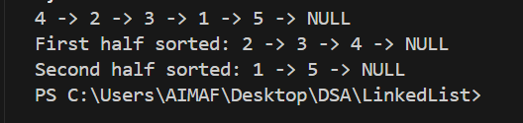

Q#3: Theme Park Shuttle Service (Circular Linked List)
A theme park operates a circular shuttle service where each stop is connected in a loop. Each stop has:
- Stop ID (integer)
- Stop Name (string)
- Distance to Next Stop (in kilometers)
Implement the shuttle system using a circular singly linked list in C++ with the following functionalities:
1. addStopAtEnd(int id, string name, int distance) – Insert a new stop at the end of the loop.
2. addStopAfter(int id, int newId, string newName, int distance) – Insert a new stop after a given stop ID.
3. removeStop(int id) – Remove a stop by ID while keeping the circular property intact.
4. displayRoute() – Display all stops in the order of the loop.
5. findLongestDistance() – Find and display the stop where the distance to the next stop is maximum.
Example:
Initial route: [1, Main Gate, 2km] → [2, Roller Coaster, 3km] → [3, Water Park, 5km] → back to Main Gate
After addStopAtEnd(4, Zoo, 4): [1, Main Gate, 2km] → [2, Roller Coaster, 3km] → [3, Water Park, 5km] → [4, Zoo, 4km] → back to Main Gate
After findLongestDistance(): Water Park has the longest distance (5 km) to next stop.

CODE:

#include <iostream>
using namespace std;

class Node
{
public:
int id;
string name;
int distance;
Node *next;

Node(int id, string name, int distance)
{
this->id = id;
this->name = name;
this->distance = distance;
this->next = nullptr;
}
};
class CircularLinkedList
{
Node *head;
Node *tail;

public:
CircularLinkedList()
{
head = tail = nullptr;
}

void addStopAtEnd(int id, string name, int distance)
{
Node *newNode = new Node(id, name, distance);
if (head == nullptr)
{
head = tail = newNode;
tail->next = head;
}
else
{
tail->next = newNode;
tail = newNode;
newNode->next = head;
}
}

int getLength()
{
if (head == nullptr)
{
return 0;
}
else
{
int count = 0;
Node *temp = head;
do
{
count++;
temp = temp->next;
} while (temp != head);
return count;
}
}

void addStopAfter(int id, int newId, string newName, int distance)
{
if (head == nullptr)
{
cout << "List is empty, cannot insert after id " << id << endl;
return;
}

Node *newNode = new Node(newId, newName, distance);
Node *temp = head;

do
{
if (temp->id == id)
{
newNode->next = temp->next;
temp->next = newNode;

if (temp == tail)
{
tail = newNode;
}

cout << "Stop added after ID " << id << endl;
return;
}
temp = temp->next;
} while (temp != head);

cout << "Stop with ID " << id << " not found!" << endl;
}

void removeStop(int id)
{
if (head == nullptr)
{
cout << "List is empty, cannot delete id " << id << endl;
return;
}

Node *curr = head;
Node *prev = tail;

do
{
if (curr->id == id)
{
if (head == tail)
{
delete head;
head = tail = nullptr;
cout << "List is now empty.\n";
return;
}

Node *del = curr;

if (curr == head)
head = head->next;
if (curr == tail)
tail = prev;

prev->next = curr->next;

delete del;
cout << "Stop with ID " << id << " deleted successfully.\n";
return;
}

prev = curr;
curr = curr->next;
} while (curr != head);

cout << "Stop with ID " << id << " not found!" << endl;
}

void displayRoute()
{
if (head == nullptr)
return;

Node *temp = head;

do
{
cout << temp->id << "-> ";
cout << temp->name << "-> ";
cout << temp->distance << " km -> ";
temp = temp->next;
} while (temp != head);
cout << "Back to start" << endl;
}

void displayLongestDistance()
{
if (head == nullptr)
return;

Node *temp = head;
int maxDistance = temp->distance;
int maxId = temp->id;

temp = temp->next;

while (temp != head)
{
if (temp->distance > maxDistance)
{
maxDistance = temp->distance;
maxId = temp->id;
}
temp = temp->next;
}

cout << "Highest Distance is " << maxDistance << " km of id " << maxId << endl;
}

};

int main()
{
CircularLinkedList cll;
int choice;
int id;
string name;
int distance;
int newId;
string newName;
int newDistance;
while(true){
cout << "Which operation you want to perform" << endl;
cout << "1 : Insert a new stop at the end of the loop." << endl;
cout << "2 : Insert a new stop after a given stop ID." << endl;
cout << "3 : Remove a stop by ID while keeping the circular property intact." << endl;
cout << "4 : Display all stops in the order of the loop." << endl;
cout << "5 : Find and display the stop where the distance to the next stop is maximum." << endl;
cout << "6 : Exit.." << endl;
cout << "Enter your choice : ";
cin >> choice;
if (choice == 1)
{
cout << "Enter id (start from zero and move in sequence) : ";
cin >> id;
cout << "Enter name of stop : ";
cin >> name;
cout << "Enter distance of stop : ";
cin >> distance;
cll.addStopAtEnd(id, name, distance);
}
else if (choice == 2)
{
cout << "Enter id : ";
cin >> id;
cout << "Enter new id : ";
cin >> newId;
cout << "Enter name of new stop : ";
cin >> newName;
cout << "Enter distance of new stop : ";
cin >> newDistance;
cll.addStopAfter(id, newId, newName, newDistance);
}
else if (choice == 3)
{
cout << "Enter target id : ";
cin >> id;
cll.removeStop(id);
}
else if (choice == 4)
{
cll.displayRoute();
}
else if (choice == 5)
{
cll.displayLongestDistance();
}
else if (choice==6){
cout << "Exiting..." << endl;
break;
}else{
cout << "invalid choice.." << endl;
}
}

return 0;
}

OUTPUT: (too long so just copy passed terminal checks)
PS C:\Users\AIMAF\Desktop\DSA\LinkedList> cd "c:\Users\AIMAF\Desktop\DSA\LinkedList\" ; if ($?) { g++ ThemePark.cpp -o ThemePark } ; if ($?) { .\ThemePark }
Which operation you want to perform
1 : Insert a new stop at the end of the loop.
2 : Insert a new stop after a given stop ID.
3 : Remove a stop by ID while keeping the circular property intact.
4 : Display all stops in the order of the loop.
5 : Find and display the stop where the distance to the next stop is maximum.
6 : Exit..
Enter your choice : 1
Enter id (start from zero and move in sequence) : 1
Enter name of stop : Rawalpindi
Enter distance of stop : 34
Which operation you want to perform
1 : Insert a new stop at the end of the loop.
2 : Insert a new stop after a given stop ID.
3 : Remove a stop by ID while keeping the circular property intact.
4 : Display all stops in the order of the loop.
5 : Find and display the stop where the distance to the next stop is maximum.
6 : Exit..
Enter your choice : 2
Enter id : 1
Enter new id : 2
Enter name of new stop : Lahore
Enter distance of new stop : 14
Stop added after ID 1
Which operation you want to perform
1 : Insert a new stop at the end of the loop.
2 : Insert a new stop after a given stop ID.
3 : Remove a stop by ID while keeping the circular property intact.
4 : Display all stops in the order of the loop.
5 : Find and display the stop where the distance to the next stop is maximum.
6 : Exit..
Enter your choice : 4
1-> Rawalpindi-> 34 km -> 2-> Lahore-> 14 km -> Back to start
Which operation you want to perform
1 : Insert a new stop at the end of the loop.
2 : Insert a new stop after a given stop ID.
3 : Remove a stop by ID while keeping the circular property intact.
4 : Display all stops in the order of the loop.
5 : Find and display the stop where the distance to the next stop is maximum.
6 : Exit..
Enter your choice : 5
Highest Distance is 34 km of id 1
Which operation you want to perform
1 : Insert a new stop at the end of the loop.
2 : Insert a new stop after a given stop ID.
3 : Remove a stop by ID while keeping the circular property intact.
4 : Display all stops in the order of the loop.
5 : Find and display the stop where the distance to the next stop is maximum.
6 : Exit..
Enter your choice : 3
Enter target id : 1
Stop with ID 1 deleted successfully.
Which operation you want to perform
1 : Insert a new stop at the end of the loop.
2 : Insert a new stop after a given stop ID.
3 : Remove a stop by ID while keeping the circular property intact.
4 : Display all stops in the order of the loop.
5 : Find and display the stop where the distance to the next stop is maximum.
6 : Exit..
Enter your choice : 6
Exiting...
PS C:\Users\AIMAF\Desktop\DSA\LinkedList>

Q#4: Text Editor Memory Management (Circular Linked List)
You are tasked with managing text in memory for a text editor application. The editor needs to efficiently handle various operations on the text. Your goal is to implement these functionalities using a circular linked list in C++:
1. insert() – Insert a new word into the text editor's memory.
2. undo() – Delete the last word added when the 'Undo' command is given.
3. find_and_replace() – Search for a word and replace it with a new word.
4. count() – Count and return the total number of words currently stored.
5. gotoNext() – Move the cursor to the next word. If at the last word, wrap around to the first word.

CODE:
#include <iostream>
using namespace std;
class Node{
public:
string data;
Node* next;
Node(string val){
data=val;
next=nullptr;
}
};

class CircularLinkedList{
public:
Node* head;
Node* tail;
Node* cursor;

CircularLinkedList(){
cursor=head=tail=nullptr;

}

void insertAtTail(string val){
Node* newNode=new Node(val);
if(head==nullptr){
head=tail=cursor=newNode;
tail->next=head;
}else{

tail->next=newNode;
cursor=tail=newNode;
newNode->next=head;
}
}

void undo(){
if(head==nullptr){
cout << "List is empty" << endl;
return;
}
if(head->next==head){
delete head;
head=nullptr;
return;
}
Node* temp=head;
do{
temp=temp->next;
}while(temp->next->next!=head);
Node* del=temp->next;
temp->next=head;
cursor=tail=temp;
delete del;

}

void search_update(string word,string newWord){
if(head==nullptr){
cout << "List is empty" << endl;
return;
}
Node* temp=head;
bool found = false;
do{
if(temp->data==word){
temp->data=newWord;
cursor=temp;
cout << "Update Succesfull!" << endl;
found=true;
break;
}
temp=temp->next;
}while(temp!=head);
if(found==false){

cout << "word not found!" << endl;
}
cout << "Deleted Last Stored word" << endl ;
}

void count(){
if(head == nullptr && tail == nullptr){
cout << "List is empty" << endl;
return;
}else{
int count=0;
Node* temp=head;
do{
count++;
temp=temp->next;
} while(temp!=head);
cout << "Count is " << count << endl;
}
}
void moveToNext(){
cout << "cursor was on " << cursor->data << endl;
if(cursor!=nullptr){
cursor=cursor->next;
}
cout << "cursor is now on " <<cursor->data << endl;
}
void display(){
Node* temp=head;
do{
cout << temp->data << "->" ;
temp=temp->next;
}while (temp!=head);
cout << "Back to head" << endl;
}
};

int main() {
CircularLinkedList cll;
cll.insertAtTail("Syeda");
cll.insertAtTail("Aima");
cll.insertAtTail("Abbas");
cll.insertAtTail("naqvi");
cll.display();
cll.count();
cll.search_update("naqvi","naqvii");
cll.display();
cll.undo();
cll.display();
cll.moveToNext();
return 0;
}

OUTPUT:
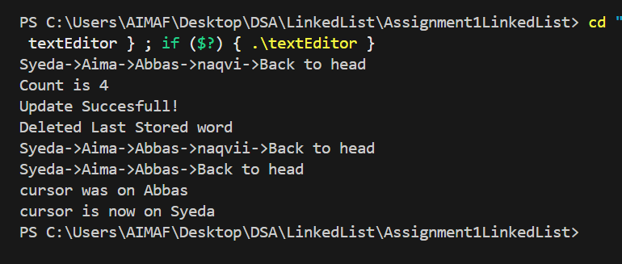

Q#5: Web Browser Tab Manager (Doubly Linked List)
Design a Tab Manager for a web browser that handles multiple open tabs. Each tab contains:
- A unique Tab ID (integer)
- Website title (string)
- URL (string)
Use a doubly linked list in C++ to implement the following operations:
1. openTab() – Open a new tab and add it to the tab list.
2. closeTabByID(int id) – Close an existing tab given its Tab ID.
3. switchTab(int id) – Switch directly to a tab by its ID.
4. displayTabsForward() – Show all open tabs in forward order.
5. displayTabsReverse() – Show all open tabs in reverse order.

CODE:

#include <iostream>
using namespace std;
class Node{
public:
int id;
string title;
Node* prev;
Node* next;
Node(int id,string title){
this->id=id;
this->title=title;
this->prev=nullptr;
this->next=nullptr;
}

};
class DoublyLinkedList{
public:
Node* head;
Node* tail;
Node* current;
DoublyLinkedList(){
head=nullptr;
tail=nullptr;
current=nullptr;
}
// inserting new node at tail and current will point to that newly insert node which is also active tab
void openTab (int val,string title){
if (head==nullptr){
Node* newNode= new Node(val,title);
head = tail = current = newNode;
return;
}
Node* newNode= new Node(val,title);
tail->next = newNode;
newNode->prev = tail;
tail = newNode;
current = newNode;
}

//deleting node with id given by user
void closeTabByID(int id){
if(head==nullptr){
cout << "List is empty" << endl;
return;
}
Node* temp=head;
while(temp!=nullptr){
if(temp->id==id){
if(temp==head && temp==tail){
head = tail = current = nullptr;
}else if(temp==head){
head=head->next;
head->prev=nullptr;
}else if(temp==tail){
tail=tail->prev;
tail->next=nullptr;
}else{
temp->prev->next=temp->next;
temp->next->prev = temp->prev;
}
if (current == temp) {
if (temp->next != nullptr)
current = temp->next;
else
current = temp->prev;
}
delete temp;
cout << "Tab with ID " << id << " closed." << endl;
return;
}
temp=temp->next;
}
cout << "Tab with ID " << id << " not found." << endl;
}

//displaying tab user gave id of and setting current to this tab
void switchTab(int id) {
if(head==nullptr){
cout << "List is empty" << endl;
return;
}
Node* temp=head;
bool found=false;
while(temp!=nullptr){
if(temp->id==id){
current=temp;
cout << temp->id << "->" << temp->title << endl;
found=true;
break;
}
temp=temp->next;
}
if(found==false){
cout << "Tab Not Found" ;
}
}

void displayTabsForward()
{
if (head == nullptr)
return;

Node *temp = head;
while(temp!=nullptr){
cout << temp->id << "-> ";
cout << temp->title << "-> ";
temp = temp->next;
}
cout << "NULL" << endl;

}
void displayTabsReverse()
{
if (head == nullptr)
return;

Node *temp = tail;
while(temp!=nullptr){
cout << temp->id << "-> ";
cout << temp->title << "-> ";
temp = temp->prev;
}
cout << "NULL" << endl ;
}
};

int main() {
DoublyLinkedList dll;
dll.openTab(1,"Google");
dll.openTab(2,"Youtube");
dll.openTab(3,"Netflix");
dll.openTab(4,"NetMirror");
dll.openTab(5,"LinkedIN");
dll.displayTabsForward();
dll.closeTabByID(2);
dll.switchTab(1);
dll.displayTabsForward();
dll.displayTabsReverse();
return 0;
}

OUTPUT:
